Q1 | Import a CSV file of food delivery orders (with columns like order_id, restaurant_name, customer_name, order_amount, order_date) into a new SQL table named FoodOrders using your database tool of choice.
Code | CREATE TABLE FoodOrders ( order_id INT AUTO_INCREMENT, restaurant_name VARCHAR(100), customer_name VARCHAR(100), order_amount DECIMAL(10,2), order_date DATE, PRIMARY KEY(order_id) );  SELECT * from foodorders;
Output | 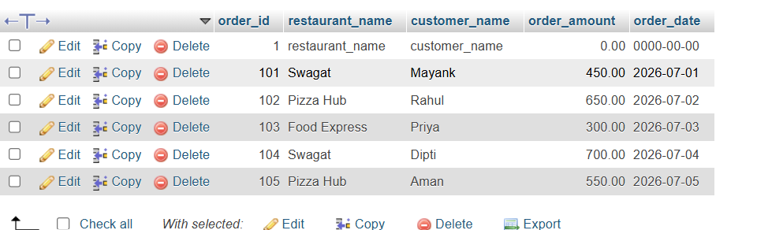

Q2 | Write SQL statements to create a table called TopSongs with columns: song_id, song_title, artist, streams, and release_date, then insert at least 5 records representing popular tracks from Spotify.
Code | Create table tops song:  CREATE TABLE TopSongs ( song_id INT AUTO_INCREMENT, song_title VARCHAR(100), artist VARCHAR(100), streams BIGINT, release_date DATE, PRIMARY KEY(song_id) );  Insert record:  INSERT INTO TopSongs VALUES (1,'Blinding Lights','The Weeknd',4200000000,'2019-11-29'), (2,'Shape of You','Ed Sheeran',3900000000,'2017-01-06'), (3,'Someone You Loved','Lewis Capaldi',3200000000,'2018-11-08'), (4,'As It Was','Harry Styles',2900000000,'2022-04-01'), (5,'Dance Monkey','Tones and I',3100000000,'2019-05-10');  Show table:  SELECT * FROM topsongs;
Output | 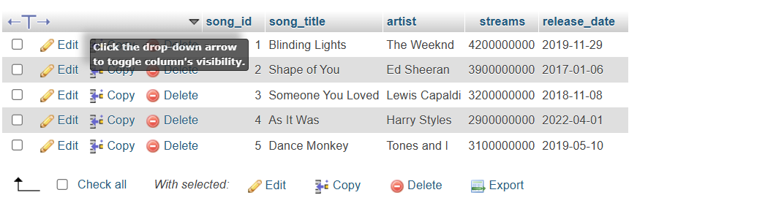

Q3 | Write an SQL query to find the top 3 customers who ordered the most from the FoodOrders table based on total order_amount, and display their names and total spent.
Code | SELECT customer_name, SUM(order_amount) AS total_spent FROM FoodOrders GROUP BY customer_name ORDER BY total_spent DESC LIMIT 3;
Output | 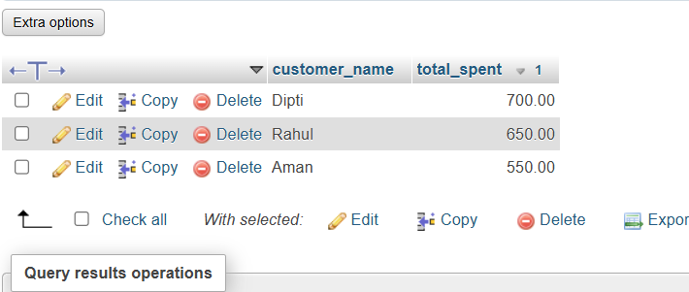

Q4 | Generate a product performance report by writing an SQL query that lists each restaurant_name from FoodOrders, the number of orders, and the total order_amount, ordered by total order_amount descending.<br><br><em><strong>Hint:</strong> Use GROUP BY and ORDER BY clauses.</em>
Code | SELECT restaurant_name, COUNT(order_id) AS total_orders, SUM(order_amount) AS total_order_amount FROM FoodOrders GROUP BY restaurant_name ORDER BY total_order_amount DESC;
Output | 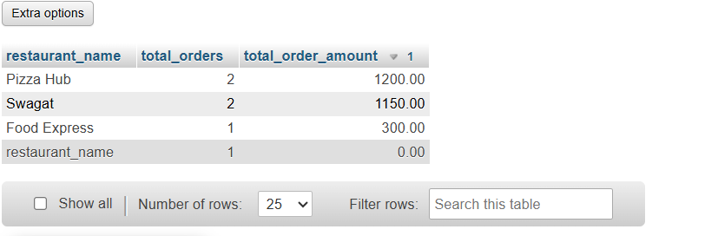

Q5 | Create an SQL query that calculates two KPIs for the FoodOrders table: (1) average order_amount and (2) total number of unique customers, and format the output for dashboard display (two columns: kpi_name, kpi_value).
Code | SELECT 'Average Order Amount' AS kpi_name, AVG(order_amount) AS kpi_value FROM FoodOrders UNION ALL SELECT 'Unique Customers', COUNT(DISTINCT customer_name) FROM FoodOrders;
Output | 